Geometry Name \_\_\_\_\_\_\_\_\_\_\_\_\_\_\_\_\_\_\_\_\_\_\_\_\_\_\_\_\_\_\_\_\_\_\_\_\_Date \_\_\_\_\_\_\_\_\_\_\_\_\_

Chapter 6 Review

Quadrilaterals Hour \_\_\_\_\_\_\_\_

1) Find the sum of the measures of the interior angles of a convex 20-gon.

2) Find the sum of the measures of the exterior angles of a convex 13-gon.

3) If each interior angle measure of a regular polygon is $144°$, find each exterior angle measure.



4) For parallelogram *BCDE*, find *x*.

5) Name 5 properties of a parallelogram.



6) Find *x* and *y* so that *ABCD* will be a parallelogram.



7) Find the missing angle measures.

8) Parallelogram *ABCD* has vertices *A*(0, 0), *B*(2, 4), *C*(10, 4). Find a pair of coordinates for *D*.

9) Name two properties rectangles have that rhombi don’t necessarily have.

10) *ABCD* is a rectangle with diagonals. If *AC* = 2*x* + 12 and *BD* = 46, find *x*.

11) *ABCD* is a rectangle with *B* (-6, 0), *C* (2, 0), and *D* (2, 4). Find the coordinates of *A*.

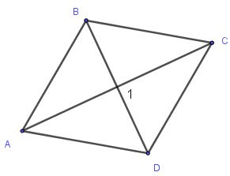

12) For rhombus *ABCD*, find .

D:\media\we\gln_ma_geom_ch06_63-64\images\pg64_004.jpg13) Find  in this square. 14) In trapezoid *DEFG*, find .

[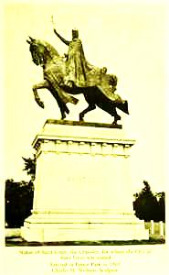](http://exhibits.slpl.lib.mo.us/images/pixel/ger00209.gif)

15) The base of a statue at the park is the shape of a trapezoid. The lower edge

is 56 inches and the upper edge is 40 inches. An engraved plaque will be

centered on a face of the trapezoid surface. What is the width of the median?

16) The length of one trapezoid base is 44, the median is 36, and the other base is 2*x* + 10. Find *x*.



17) Find AB in this trapezoid with median XY.

18) *ABCD* is a rectangle with *A*(0, 0), *B*(*b*, 0), and *D*(0, *a*). Find the coordinates of *C*.



19) Find all the missing information

you can for this parallelogram.

20) Suppose you position a square in the coordinate plane and label its coordinates.

How would you prove that the diagonals of the square bisect each other?

21) Show why this is a parallelogram. Include work that’s easy to follow.

