… SHOW YOUR WORK …
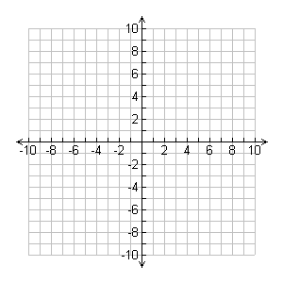
1) Give the equation of a line parallel to the line through R(-2,-3) and T(8,1).

2) Graph both the new line and $\overset{⃡}{RT}$.

3) Write an equation for the line through (8,3) that is perpendicular to $y= \frac{1}{2}x+5$.

4) Andy is reading a novel. At 9:00, he had read 90 pages. At 12:00, he had read 330 pages.

5) What is Andy’s average reading speed between 9:00 and 12:00?

6) How many pages would Andy read by 2:30?

