**Objective**: This project gives practical hands-on experience using similar triangles and geometric mean. You ***calculate*** a height using ***measurements*** made at ground level. Use two measurements to create your similar triangles situation. One measure is eye height and the other is distance to object.

**Who**: Table groups in each Geometry class

**Due**: Wednesday, February 12 (end of class)

**Required elements:**

**Names, Date, Hour (3 pts)**

Print one copy for your table.

**Neatness (2 pts)**

Type your paper. Use a ruler as needed.

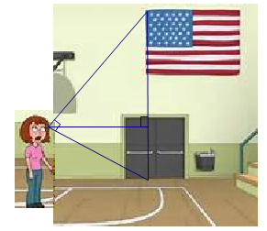

**Sketch or Photo (5 pts) 🡪**

Assign ***letters***to the points. Indicate your ***measurements***.



**Simplified Illustration (5 pts) 🡪**

***Redraw*** a simple version of the right triangle oriented like the examples in class. Label parts.

**Calculations (3 pts)**

Write a proportion. Show your calculations.

**Final Answer (2 pts)**

Tell the height of the object. Use units (feet and/or inches) and **circle** your answer.